// Om Sree Gurubhyo Namah //

**JAI MEENA 2**

MAGICAL MYSTERY OF 8TH HOUSE



***~ Dr. R. Chandra Lekha***

Dr. R. Chandra Lekha is a faculty in JKR Astro Research Foundation. She is a staunch follower of Meena 2 Naadi System and a disciple of Dr. NVRA. Raja, Meena 2 Junior. She is currently pursuing her Msc Psychology and completed her MA (Astrology) from Yoga Samskrutham University and also MA Astrology from Potti Sreeramulu Telugu University. She has been awarded with PhD for her research on “Medical Astrology – Breast Cancer – Based on Meena 2 Naadi Principles” from Yoga Samskrutham University, Florida, USA. She is the recipient of number of astrology titles. ***lekhanainu@gmail.com***

|  |
| --- |
| **Author’s Note:**  **The topic that I chose to write about is Eighth House. The myth about eighth house is that it’s treated as a negative house in astrology, it signifies the death of a physical body, obstacles, hidden things, sexual controversies, dowry, sudden events, accidents, disgrace, sorrow, delays and it is also called Dusthana house, along with 6th and 12th. The question then, is whether Eighth a very malefic house is really! So, I chose this topic which will give some insight on other phases of Eight house.** |

Lagna shows the outer self and 8th house is the inner power.

* Kundalini Shakti or Serpent power resides in natural Scorpio sign owned by Mars.
* Natural Eighth house is Scorpio the constellations which are in this sign are Vishaka 4pd, Anuradha 1,2,3,4 and Jyestha 1,2,3,4. Moon gets debilitated in Scorpio. According to Meena 2 Naadi, Raghavacharyam says the Rahu and Ketu gets exalted in Scorpio.
* The constellation Vishaka 4pada in Navamsa falls in Cancer sign an exaltation sign of Jupiter. Anuradha 4pd in Navamsa falls in Scorpio sign – Raghavacharyam says that Saturn in Anuradha constellation is more powerful than the House lord Mars, and Jyesta 4pd in Navamsa falls in Pisces sign – Raghavacharyam says that Mercury in Mercury constellation will nullifies the effects of its debilitation.

**Importance of Scorpio sign**

The constellation allotted in this sign are Vishaka (Satwic), Anuradha (Tamas) and Jyestha (Satwic) – 2 satwic is hemming between a tamasic.

* Vishaka – Jupiter in 8th house is good for spiritual and gives amazing insights and thoughts.
* Anuradha – Saturn karaka for Ayursthana in 8th house is good for longevity. Saturn being lord of Mooladhara Chakra first disturbed here due to imbalanced mundane desires arise after sufferings, delays, hurdles and out of these difficulties it makes person first empty hand and further those disappointments make you more closer towards to divine path leading to kundalini energies – towards higher chakras.
* Jyestha – Mercury the karaka of Buddhi or Mind if afflicted in 8th house indicates Witchcraft or Black magic – disturbance in Prana Vayu. This is the reason why Moon gets debilitated where the natives mind gets influenced. “The Scorpion” bite usually gives neurological shock that is unbearable for any being and the same way Witchcraft work in 8th first and effects mind of the native in a much deeper level that is hard for anyone.
* 8th being fallen in 12th from 9th house which indicates past birth – shows what is left behind that you have to face in any case or finish or exhaust it.
* Rahu (Maya ) in 8th house creates sensitive situation. It gives deep thoughts and research abelites but can make one addictive and can lead one into bad deeds. The desire to achieve the goal will be very high and to any extent .
* Ketu (Moksha) karaka for detachment. If Ketu in 8th house and if aspected by 12th house posited Jupiter indicates occultism and higher spirituality – pending karma, amazing intuition.
* Mars in 8th house make energetic, over enthusiastic , strong will power, innocence, wisdom, purity, strength, lustful and intense.
* **KARAKATWAS OF EIGHTH HOUSE**
* It is the indicator of easy money not hard earned money i.e. , a kind of money earned by illegal means through corruption. After demise i.e. , death after inheritance, lottery, insurance, scholarships, wealth of in-laws.
* House of Mystery and misery, misfortune, mental anxiety, sorrow and strife, worries, delays and dejections, blame and ill reputation, accident, fear, imprisonment, doing wrong actions, conspiracy.
* House of Knowledge, Occultism, Research, Yantra, Mantra, tantras, Yogis, divine path and awakening Kundalini shakti.
* Eighth house is life transforming incidents, exploration, sexuality, long term chronic illness, scandals, addictions, fear, hidden treasures which is deep inside the ground, longevity, karaka Saturn, lottery, inheritance, tantric activities, spiritual growth and interest in occult subjects.
* Eighth house is like a mother’s womb where all the secrets are hidden in depth. Its represents the darker side of the world. Your secrets or anything which you do not share with anyone.
* Strong Eighth house related professions are Psychologist, Psychiatrist , Doctors, Counsellors since they will dig deep within you.
* Body parts governed by 8th house in natural zodiac is reproductive system.
* In Mundane Astrology, Eighth house represents natural calamities, death of politician or prominent person, celebrity, Loss of battles, Import, Export, Scarcity, Archeology and mining's.
* Placement of 8th lord in Kendra's or Trikones bhavas shows long life.
* In Trik bhavas or with affliction from Rahu and Ketu shows issues of health and Sudden ups and down.

**Astrological Combination for religious or spiritual practices.**

1. The connection of Dharma trikona i.e., 1,5 and 9 houses/lords with Moksha trikona 4,8 and 12.
2. The Ketu placement in 12th from Moon can give good level of intuitive ability.
3. If Ketu is aspected by Jupiter.
4. During the Dasa of 5th lord or 9th lord or planet associated with these houses lords especially if they are benefic planets makes one spiritually or religiously inclined during its DBA.
5. During the mahadasa of Rahu or Ketu associated with 5th or 9th lord and receiving the aspect of Jupiter is also helpful in Spiritual growth.
6. The planets in ‘Sarpa Drekkana’ for spiritual inclination. The 2nd and 3rd Drekkana of Cancer, 1st and 2nd Drekkana of Scorpio and 3rd Drekkana of Pisces are Sarpa Drekkana.

**Narayana Guru, a saint and social reformer who fought against the ill effects of the caste system and preached “One Caste, One Religion, One God” for all. Born in a small village this saint did not found any new religion but propagated the principles of Advaita like Bhagavan Sri Ramana Maharishi. Sri Narayana Guru deep-dived into spirituality and used his knowledge to weed out superstitions, promote cleanliness, equality and enterprise.**

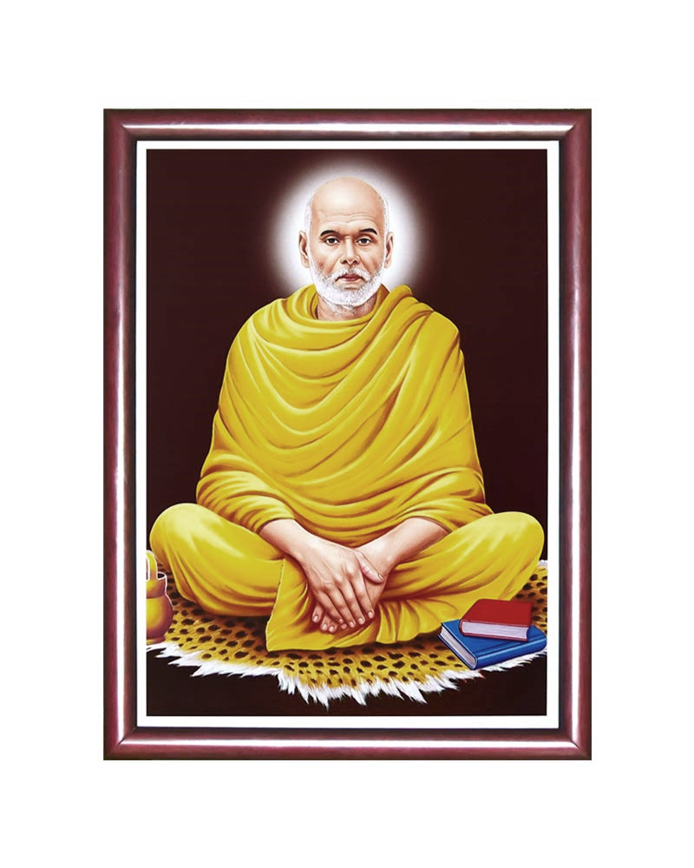

**Strong 8th house which indicates transformation. Sri Narayana Guru has been credited with transforming the social fabric of Kerala. Guruji stressed the need for the spiritual and social upliftment of the downtrodden by their own efforts through the establishments of temples and educational institutions. Guru is the founder of Advaita Ashram in Kalady. Guru had mastered various Yogic practices including Hatha Yoga and moved**

**wilderness of Maruthwamala where he established a hermitage and lived a secluded life immersed in mediative thoughts and yoga.**

**Here is the chart of Yoga guru who has in his early life took to practice yoga, meditation and maintained the pure spiritual life throughout. The great saints for whom Siddhis become a part of their lives, the period of success of their sadhana should be seen. Therefore, their siddhis continue with them.**

**Date of Birth: 28.08.1855, Time of Birth: 6.15am,**

**Place of Birth: Chempazhanty, Trivandrum.**

|  |  |  |  |  |  |  |  |  |
| --- | --- | --- | --- | --- | --- | --- | --- | --- |
|  |  |  |  |  |  |  |  |  |
|  | **Rahu** |  | **Saturn** |  | **Moon** |  |  |  |
| **(Jup)** |  |  |  |  |  |  |  | **Lagna** |
| **Moon** |  |  | **Mars** |  | **Ketu** |  |  | **Sun/ven** |
|  | **RASI** |  | **Lagna** |  |  | **D - 9** |  | **Rahu/**  **Mars/** |
|  |  |  | **Sun**  **Mer** |  |  |  |  | **Mer** |
|  |  | **Ketu** | **Venus** |  | **Sat** |  |  |  |
|  |  |  |  |  | **Jup** |  |  |  |

|  |  |  |  |  |
| --- | --- | --- | --- | --- |
| **Asc** | **Leo** | **Magha** | | **4pada** |
| **Sun** | **Leo** | **Magha** |  | **4pada** |
| **Moon** | **Aqu** | **Satabhisha** | | **4pada** |
| **Mars** | **Cancer** | **Pushyami** | | **1pada** |
| **Mercury** | **Leo** | **Pubba** | | **1pada** |
| **Jupiter** | **Aqu** | **Satabhisha** |  | **1pada** |
| **Venus** | **Virgo** | **Hasta** | | **4pada** |
| **Saturn** | **Gemini** | **Aridra** | | **1pada** |
| **Rahu** | **Aries** | **Bharani** | | **1pada** |
| **Ketu** | **Libra** | **Swathi** | | **3pada** |

* Lagna lord Sun in own house and in the star of Ketu. Ketu will deliver the results of Venus and its starlord Rahu. Strong Lagnalord Sun and its starlord Ketu is aspected by yogakaraka and 8th lord Jupiter a satwic planet.
* Mercury the lord of 2nd and 11th gets digbala in Lagna Kendra. Mercury the lord of kutumbha is in vargottama and is aspected by 5th and 8th lord Jupiter indicates astounding intuitive powers. Mercury conjunct with Sun gave Budhaditya yoga in lagna and gave a strong will power.
* Venus the lord of 3rd and 10th is in the star of Moon and starlord Moon is aspected by 4th lord Mars. Venus gets Digbala. Venus is debilitated in 2nd house indicating that the Guru talked less and put his ideas into practice through his poetry.
* Mars the lord of 4th and 9th lord is in the star of Saturn. Mars in debilitation and in 12th house of mokshasthana. Mars aspecting 5th and 8th lord Jupiter and 12th lord moon indicates that all knowledge that the Guru had was self-acquired. The Guru left his home and followed divinity throughout his life.

5th and 8th lord Jupiter posited in the 7th house in the star of Rahu. Jupiter through Retrograde gives the results of mars star which happens to be 9th lord. Jupiter gets digbala. Jupiter is conjunct with Moon the 12th lord and aspects Ketu the karaka for salvation. Jupiter aspects Saturn posited in 11th house giving Gurumanda yoga or Dharmakarmadhipathi yoga, which made him world famous through his preaching's.

6th and 7th lord Saturn is in the star of Rahu and saturn the karaka for huge mass is aspected by 8th lord Jupiter giving him the courage in writing. 7th house posited jupiter aspects saturn gets digbala. Saturn aspects lagna and 2nd and 11th lord Mercury, because of strong connection of 1st, 2nd,11th, 5th and 8th house lords gave him Sanyasa yoga. The consecration of his revolutionary Aruvippuram Siva Idol in 1988 which led to his entry into the Sivagiri hills marked his social reformation movement which was during Saturn dasa.

12th lord Moon in the star of Rahu and Mars the 4th lord aspects Moon gets digbala. Moon is conjunct with 8th lord Jupiter – the natural 12th house which indicates feet… Guru has dedicated his life in the path of salvation. Moon the 12th lord of mokshasthanadhipathi being with 8th lord Jupiter and aspected by 9th lord of mars and lagna lord the natural 5th lord Sun indicates a pure spiritual enlightenment.

Strong connection of 8th house which indicates reciting any subjects into deeply and expressing it without fear. Here when we look into the chart of Sri Narayana Guru – the 8th lord Jupiter a satwic planet with digbala and being a yogakaraka for Leo ascendant is delivering the results of all the bhavas.

**STRONG DIGBALA ACQUIRED 8TH LORD JUPITER**

Jupiter aspects Sun (Lagna)

Jupiter aspects Mercury (2nd & 11th lord)

Jupiter conjunct with starlord of Venus (3rd & 10th lord) i.e., Moon

and aspects Ketu posited in Libra giving results of Venus.

Jupiter aspects starlord of Mars (4th & 9th lord) i.e., Saturn

Jupiter aspects Saturn (6th & 7th lord)

Jupiter is conjunct with Moon (12th lord)

Jupiter itself is in Rahu star

**NOTE ~ Even though plenty of spiritual planetary combinations are present in the horoscope… unless they are connected with lagna or moon the native… will not take it seriously. Here in this case jupiter is connected with both lagna and moon. Hence, we can say that this guru has strongly followed the path of spirituality.**

